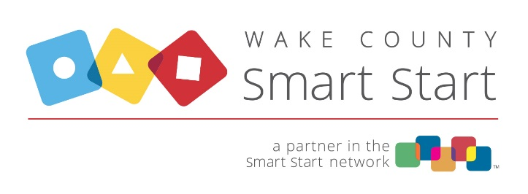
4901 Waters Edge Drive, Suite 101, Raleigh, NC 27606
Phone: (919) 851-9550 Web: www.wakesmartstart.org

ACH AUTHORIZATION FORM
Click or mark an (X) in the box beside the Request Type: New Account Set-Up ☐ Account Change ☐ *

*Any account changes must be received at least 30 days prior to disbursement in order to take effect.

Complete this form and attach a VOIDED CHECK or a letter from your bank verifying the bank’s routing number and your bank account number. Email to: WCSSPayables@wakesmartstart.org

Participating Entity Information (who will be receiving funds?)
Entity Name:
Entity Address:
Tax ID Number:
Financial Institution Account Information
Institution Name:
Institution Address:
Transit / Routing #:
Bank Account #:
Type of Account: (check one) | ☐ Checking | ☐ Savings

Participating Entity Authorization
I, on behalf of the participating entity indicated above, hereby authorize Wake County Smart Start, Inc. (WCSS) to initiate ACH credit entries to the above designated bank account for payments due from WCSS, pursuant to the Established Policies and Procedures for WCSS EFT Payments System. I (we) also authorize any necessary ACH debit entries or adjustments for any ACH credit entries made in error to the account. I (we) acknowledge the origination of ACH transactions to my (our) account must comply with the provisions of U.S. law and provisions of the National Automated Clearing House Association (NACHA) Operating Rules. The authority will remain in effect until we have cancelled it in writing.
Authorized Signer’s Name (print): |  |  |  |  | Telephone:
Signature:  Note – verified electronic signature such as via DocuSign is acceptable. |  |  |  |  | Date:
Email Address for Payment Notification
WCSS Use Only:

Updated by: _________________ Date: _____________

Approved by: _________________ Date: _____________

