Receipt Voucher for In-Kind Contribution of NON-PROFESSIONAL Volunteer Hours
Agency or Child Care Center:
Smart Start-funded Activity:
Month & Year:

I certify that I served as a volunteer to this organization for the hours as noted below and did not receive compensation for my services.
Volunteer Name (print): Signature:
Address:
Phone:

By my signature below, I acknowledge receipt of the above-mentioned volunteer services.
Authorized Employee Signature:

Date | Description of Volunteer Work | Smart Start hours
 | (Please use the decimal system in recording hours.) Total hours
 | Hourly Rate* | $30.58
 | Total Value (Carry Amount to Section C)

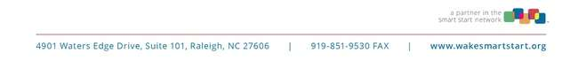
*Hourly rate is updated each year. This is current for 7/1/23 – 6/30/24.

