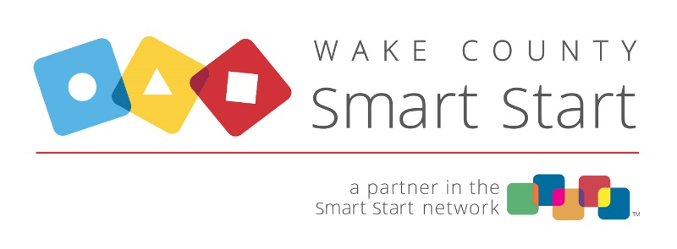

SCHEDULE OF DUE DATES, 2023-24

Due Date Type of Report Due Date Type of Report
8/10/23 FSR, July 2023 2/12/24 FSR, January 2024
Equipment > $500 (if purchased) Equipment > $500 (if purchased)

9/11/23 FSR, August 2023 3/11/24 FSR, February 2024
Equipment > $500 (if purchased) Equipment > $500 (if purchased)

10/10/23 FSR, September 2023 4/10/24 FSR, March 2024
Equipment > $500 (if purchased) Equipment > $500 (if purchased)
Q1 Quarterly Report Q3 Quarterly Report
Q1 Tracking Spreadsheet (if applicable) Q3 Tracking Spreadsheet (if applicable)

11/10/23 FSR, October 2023 5/10/24 FSR, April 2024
Equipment > $500 (if purchased) Equipment > $500 (if purchased)

12/11/23 FSR, November 2023 6/10/24 FSR, May 2024
Equipment > $500 (if purchased) Equipment > $500 (if purchased)

1/10/24 FSR, December 2023 7/10/24 FSR, June 2024
Equipment > $500 (if purchased) Equipment > $500 (if purchased)

Q2 Quarterly Report Q4 Quarterly Report
Q2 Tracking Spreadsheet (if applicable) Q4 Tracking Spreadsheet (if applicable)
Annual Program Income 2023-24

NOTE: Annual Grantee Reporting under G.S. 143C-6-23 and 09 NCAC 03M is determined by your organization's fiscal year end.

