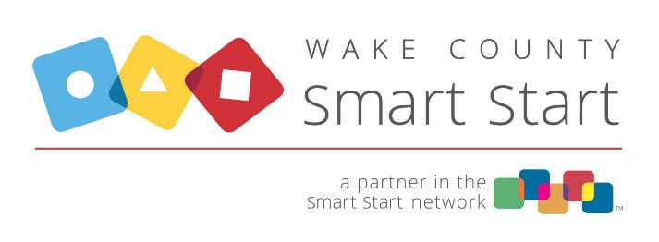

Cash and Non-Cash Grants

Grants are cash or non-cash resources such as materials or equipment for which the grantor (WCSS or Direct Service Provider) receives nothing of tangible value in return. Examples include but are not limited to:

- Grants of quality enhancement materials that have been purchased by WCSS for a child care center
- Car seat distributions
- Payments on behalf of others for expenses, including but NOT limited to registration and training fees, insurance premiums paid directly to the insurer on behalf of childcare providers
- Rewards/incentives such as classroom items not materially consumed or gift cards given for attending training. Items such as children’s books, reference/text books, and other materials not materially consumed would be considered grants if given to training participants.

Note that workbooks completed during the training would be considered materially consumed because of subsequent limited utility, and therefore would be charged to Service Related Supplies.

Grants to non-government entities require a grant agreement or memorandum of understanding that defines the purpose, amount, and responsibility of both parties. The grantee and grantor must also comply with State reporting requirements which can be accessed from the NC Office of State Budget and Management website: https://www.osbm.nc.gov/management/grants. Cash grants must be spent in compliance with Smart Start Cost Principles.

Grants to individuals require a written acknowledgment from the grantee or documentation that an award was received. For example, in the case where items are distributed at an event, an acknowledgement noting the receipt of goods for participating could be added to a sign in sheet. Individual cash awards of $600 or more per calendar year may require issuance of a 1099 to the grantee.

On the FSR, cash grants should be reported on Line 46-Cash Grants and Awards and non-cash grants on Line 47-Non-Cash Grants and Awards. Grants made by Direct Service Providers are subject to monitoring by WCSS. Monitoring consists of verifying proper documentation for grant awards and compliance with Smart Start Cost Principles.

