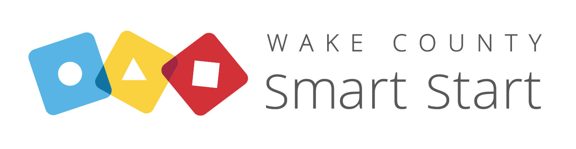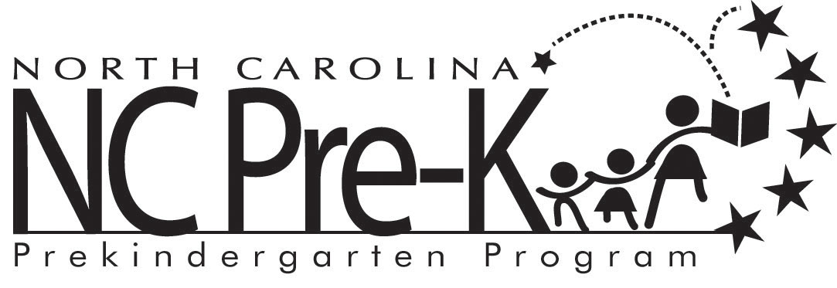

Dear Family,

Upon attendance, North Carolina Pre-Kindergarten Guidelines state that the site must have an up-to-date health assessment for your child.

Currently, we _____ Have no health assessment

_____ Have an out of date health assessment

By ____________________, we must have on file a valid health assessment for your child or your child will not be permitted to attend our site.

NC Pre-K Guidelines will require us to replace your child with another child who can meet the requirements.

Please help us to continue to serve your child by providing a copy of your child’s current health assessment.

Sincerely,

____________________________
Center Director

Dear Family,

In accordance with North Carolina Pre-Kindergarten Guidelines, we will not be able to serve your child after _______________________________________________________________

Our applications inform all families that current health assessments are required. All families were informed upon enrollment that health assessments were due upon attendance. Any family that did not bring health assessment was sent a letter requesting compliance by _____________________________. Because we cannot meet licensing and NCPK contractual requirements if we continue to serve your child, we regret to inform you that _________________ last day of attendance will be _______________.

Sincerely,

____________________________________
Center Director

